**Student Name:**

**Student ID:**

Lab 4: Network Access Control Setup

# Tools

* VM PacketFence Server (OVA)
* VM Win 7/10 Workstation
* Kali
* VM Web Server

# Topology

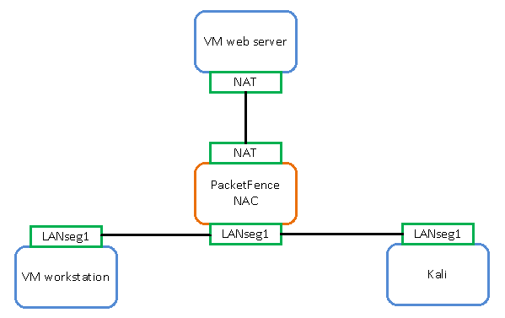

# Setup

Before you begin the lab activities, perform the steps below to set up your computer.

1. Set up a Windows workstation in a VM using ISO with the following parameters.

* 2 CPU
* 4 GB of RAM
* 80 GB HDD
* Network Adapter: NAT
* Latest version of Wireshark with Winpcap

Reconfigure the network adapter:

* Change network adapter to LAN Segment 1 in VM console
* Configure IP address to use DHCP

1. Set up Kali in the VM with the following parameters.

* Network Adapter: LAN Segment 1
* Configure the IP address to: 192.168.3.2/24
* Configure the gateway to: 192.168.3.1

1. Install an Ubuntu web server by entering the following commands:
   * $sudo apt install apache2
   * $sudo apt install net-tools

Note the IP address of the VM web server

1. Set up PacketFence in the VM using OVA by following the steps below. For further information, see the PacketFence Inline Deplyment Quick Guide using ZEN, located at <https://packetfence.org/doc/PacketFence_Inline_Deployment_Quick_Guide_ZEN.html> or <https://schoolsysadmin.blogspot.ca/2015/11/packetfence-configuration.html> or https://schoolsysadmin.blogspot.ca/2015/11/packetfence-network-access-control.html
2. Import OVA into the VM environment.
3. Change the memory to 8 GB.
4. Set Network Adapter 1 (Eth0) as: NAT
5. Add a Network Adapter 2 (Eth1)as: LAN Segment 1
6. From a computer on the NAT network, browse to: https://<packetfence_IP>:1443/configurator/
7. Set Eth0 to **Management** (VM DHCP)
8. Set Eth1 to **Inline**, Layer 2 type, with an IP address of: 192.168.3.1/24.
9. Set the DNS to DNS server in NAT network, and then enable the DHCP server and enable NAT.
10. Set up MySQL root account, database and database account.

Note:Write down the account names and passwords.

1. Skip the Fingerbank setup.
2. Start PacketFence in the confirmation page.
3. Log into the PacketFence management console.

https://<packetfence_IP>:1443/Administrator/

1. Add a user name: demouser with the password: demouser.
2. Assign user Role as **Guest** and Access duration to **5 days**.

## Appendix A: Switch Setup

